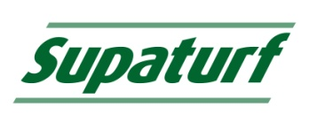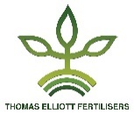
Amino-Sorb©
Amino Acid Supplement

What
Available in two differing formulations, either Amino-Sorb F, foliar absorption or Amino-Sorb R root absorption. Amino-Sorb is an Amino Acid formulation which enhances such processes as Seed Germination, Root and Shoot growth.
Amino Acids, are the precursors of Proteins necessary for many plant metabolic processes.
- Quickly absorbed through the plant’s foliage or roots.
- Natural Organic molecules.
- Increases photosynthesis rate and Chlorophyll concentration.
- Improves the efficiency of other turf treatments.

Why
Under normal conditions, plants synthesise their own amino acids. When the plant becomes stressed under conditions of draught, adverse temperature, disease or nutrient deficiency. Amino-Sorb provides the vital building blocks necessary for protein production. Speeding the plants recovery by supplying the Amino Acids that the plant would otherwise need to photosynthesise before protein production can commence.
- Available in two formulations F for foliar application and R for root absorption.
- Provides stress relief.
- Promotes healthy root growth.
- Encourages better moisture and nutrient uptake.
- Helps maintain turf quality by stimulating plant metabolism.
- Increases photosynthesis and chlorophyll concentration.
- Improves the efficiency of Herbicides and Fungicides.
- Enhances seed germination.
When
Suitable for all year round use or when stress conditions are prevalent.

Application

Amino-Sorb F
All sports surfaces – 300 to 500ml /1000m² in 30 to 50 litres of water (3 to 5 Litres / Hectare in 300 to 500 Litres of water)

Amino-Sorb R
All sports surfaces – 1 to 1.5 Litres /1000m² in a minimum of 50 litres of water (10 to 15 Litres / Hectare in a minimum of 500 Litres of water)
Thomas Elliott  Selby Place  Stanley Industrial Estate  Skelmersdale  Lancashire  WN8 8EF  info@thomas-elliott.co.uk  01695 51863 | Vitax Amenity  Owen Street  Coalville  Leicester  LE67 3DE  info@vitax.co.uk  01530 510060

